ECE 6810 Assignment No. 3 Zeyu Liu G24910689

- (a) Implement a Hamming window of length L, and plot the impulse response h(n), for L = 401.
(b) Compute the DFT of h(n) and plot the result.

% 1(a). window of length L.(L = 401)
L = 401;
h = zeros(L);
for n=1:L,
h(n) = 0.54 - 0.46*cos(2*pi*n/L);
end;
plot(h);
pause;

%or use tese is the same
%h1 = hamming(L);
%plot(h1);
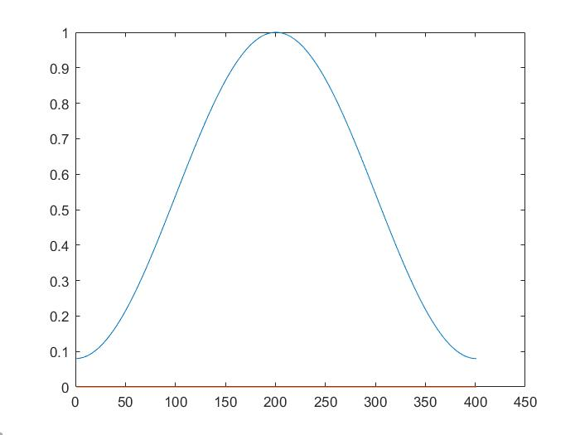
(b)The we need to add a double for h1 so ,the picture will be better.

% 1(b). Apply FFT
% h = hamming(L);
% plot(h1);
% pause;
h1 = double(hamming(L));
plot(h1);
pause;

% H = fft(h);
% logh = log(abs(H))+1;
% plot(logh);
% pause;
% plot(angle(H));
% pause;

H1 = fft(h1);
% plot magnitude
logh = log(abs(H1))+1;
plot(logh);
pause;
% plot phase
plot(angle(H1));
pause;

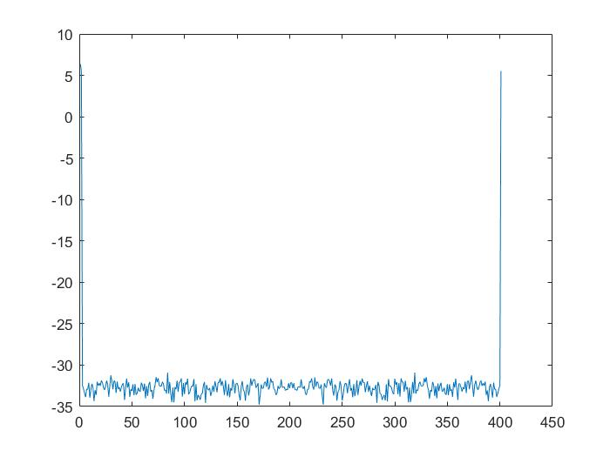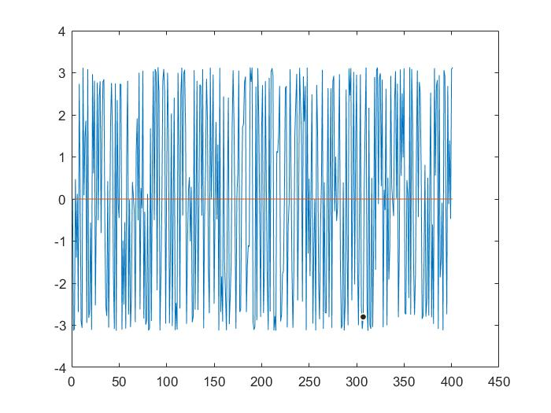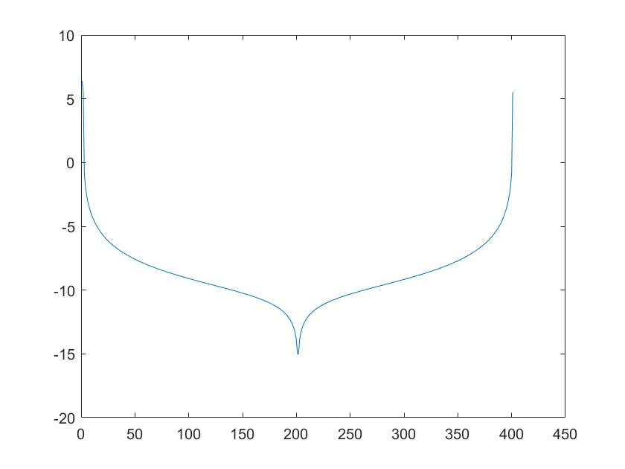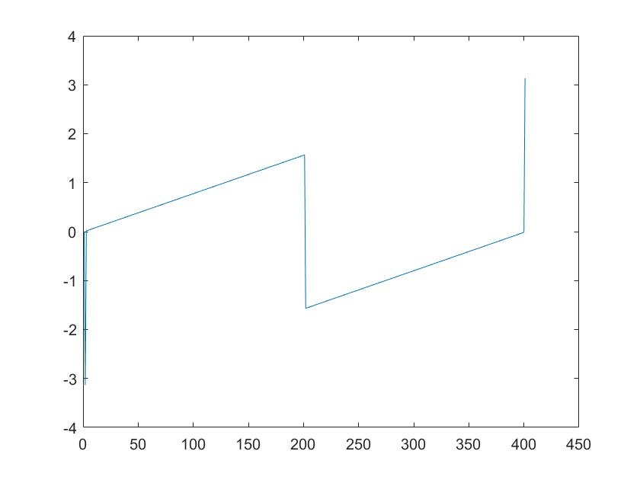

- Implement the algorithm to compute short-time energy and apply to the TIMIT speech sample for Hamming window lengths L=51, 101, 201, and 401, and down-sampling interval R = 4.

% 2. compute short-time energy and apply to the TIMIT speech sample
fname = 'LDC93s1.wav';
x = audioread(fname);
% short-time energy E = convolution(x^2(n)*h(n)), h(n) = w^2(n)
L = [51, 101, 201, 401];
for k = 1:4,
w = hamming(L(k));
h = w.^2;
y = conv(x.^2,h);
N = length(y);
for m = 1:floor(N/4),
energy(m) = y((m-1)*4+1);
end;
plot(x);
pause;
plot(energy);
pause;
end;

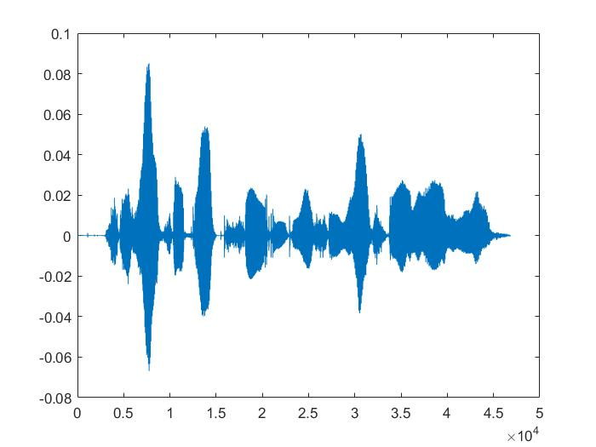
x

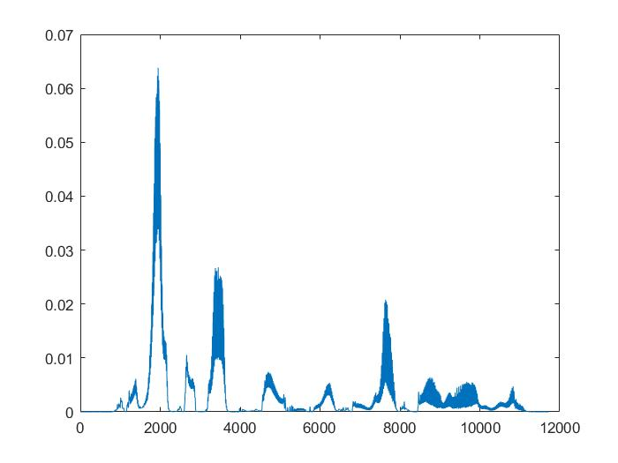
2.L=51,energy
2.L=101,energy
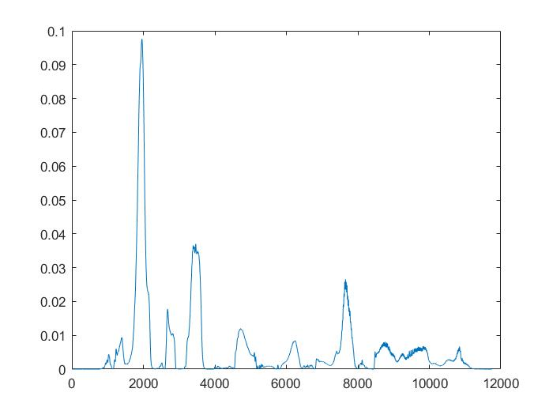
2.L=201,energy
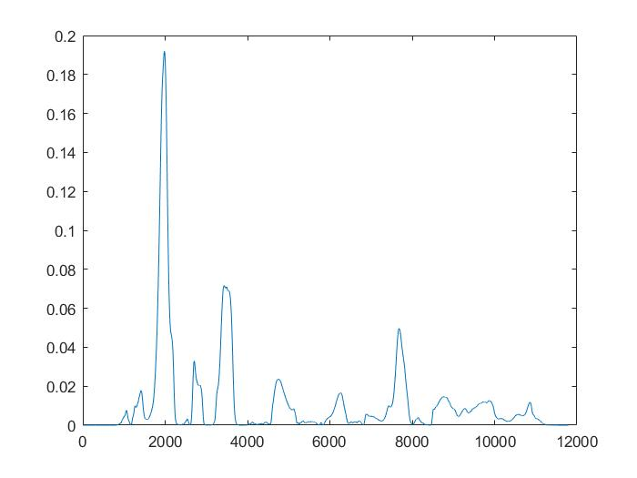
2.L=401,energy

- Repeat Problem 2 for short-time zero-crossings.

% 3. short-time zero-crossings
for k = 1:4,
w = hamming(L(k));
h = w.^2;
N = length(x)-1;
diff = zeros(1,N);
for n = 1:N,
diff(n) = abs(sign(x(n+1))-sign(x(n)));
end;
y = conv(diff,h);
M = length(y);
for m = 1:floor(M/4);
zc(m) = y((m-1)*4+1);
end;
plot(x);
pause;
plot(zc);
pause;
end;

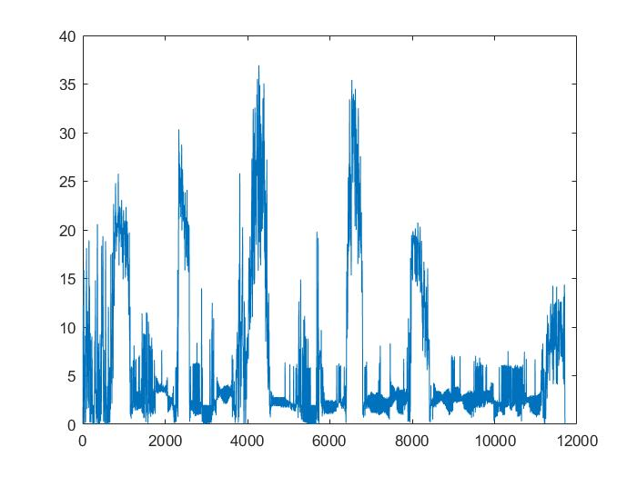
3.L=51,zc
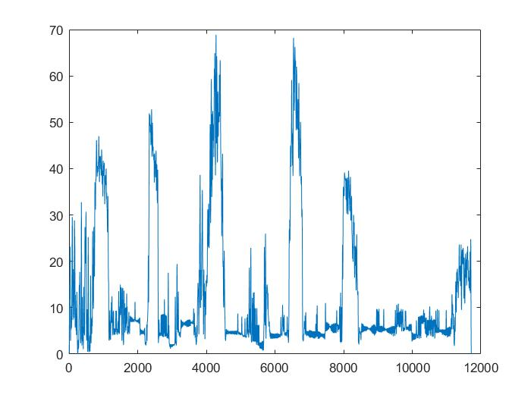
3.L=101,zc
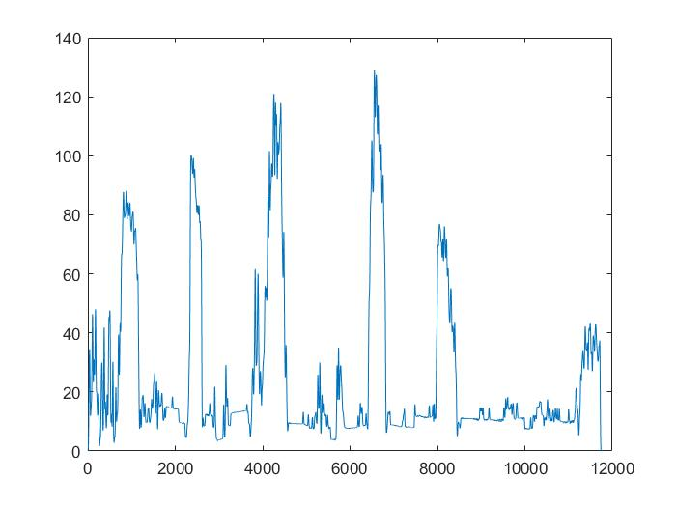
3.L=201,zc
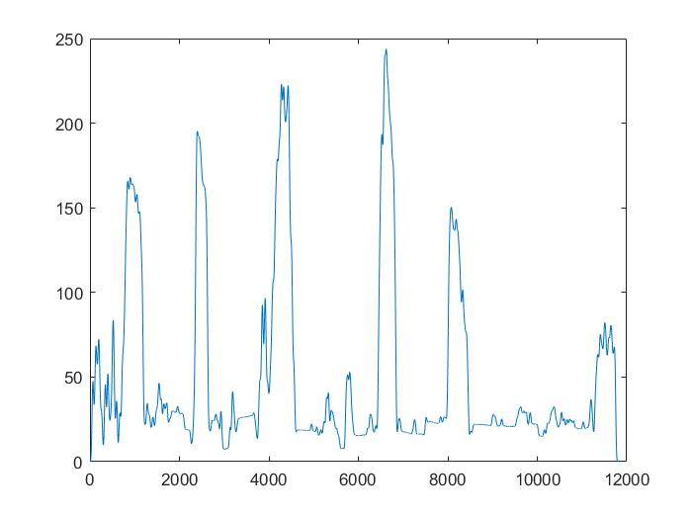
3.L=401,zc

- Implement the algorithm to compute short-time auto-correlation function, and test with TIMIT speech sample. Display results as a 2D image (time lag k as y axis, short-time index as x axis).

% 4.compute short-time auto-correlation function
% test with TIMIT speech sample. Display results
% as a 2D image (time lag k as y axis, short-time
% index as x axis).

% short-time auto-correlation function:
% R = convolution(x(n)*x(n-k)) or convolution(x(n+k)*x(n))
fname = 'LDC93s1.wav';
x = audioread(fname);
L = [51, 101, 201, 401];
% time lag k as y axis, short-time index as x axis
for k1 = 1:4,
w = hamming(L(k1));
N = length(x)-640;
co = zeros(floor(N/320),250)
for i=1:320:N,
for k=1:250,
x1 = x(i:i+320);
y1 = conv(x1,w);
x2 = x(i+k:i+k+320);
y2 = conv(x2,w);
tk(k) = y1'*y2;
end;
co((i-1)/320+1,:) = tk; %
end;
imagesc(co');
colormap(gray);
pause;
end;

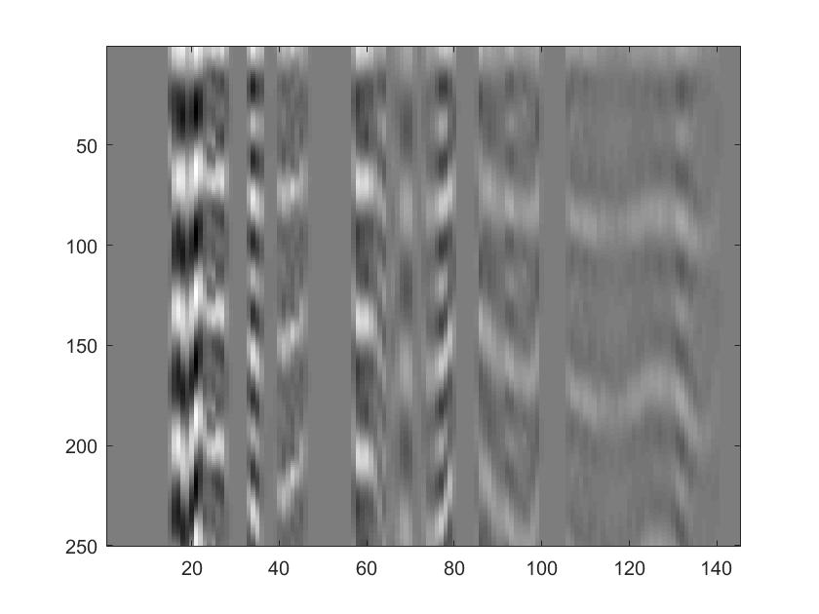
4.L=51
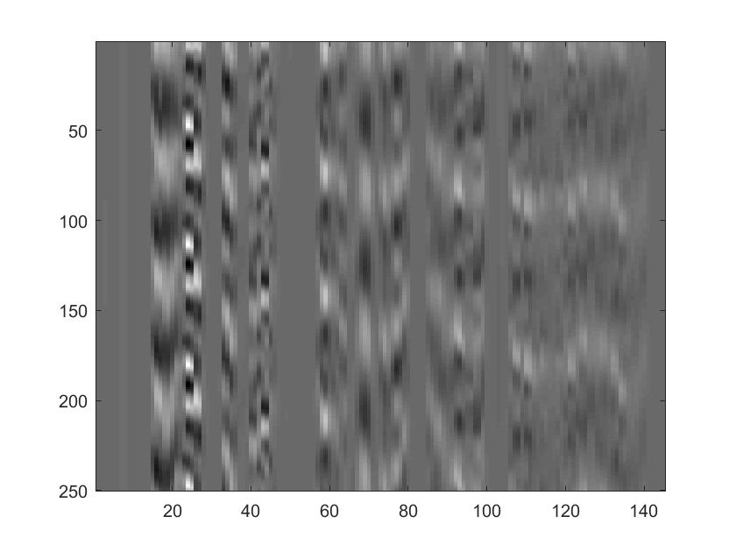
4.L=101

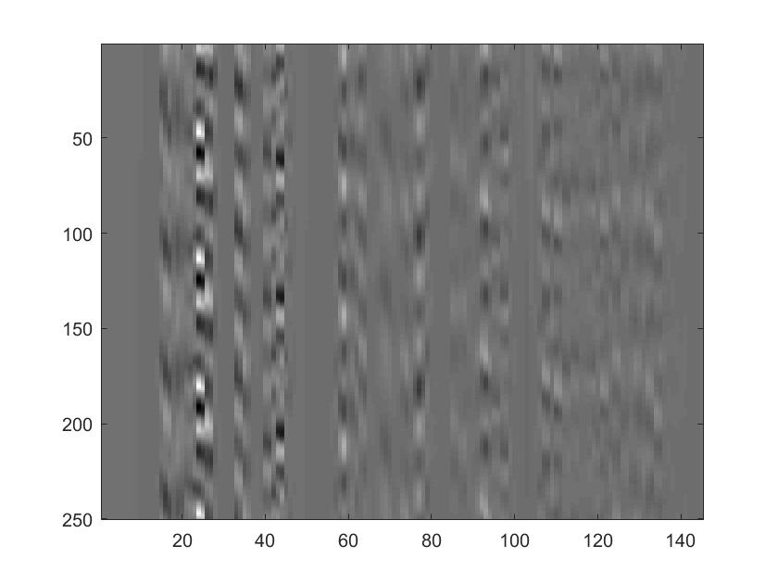
4.L=201
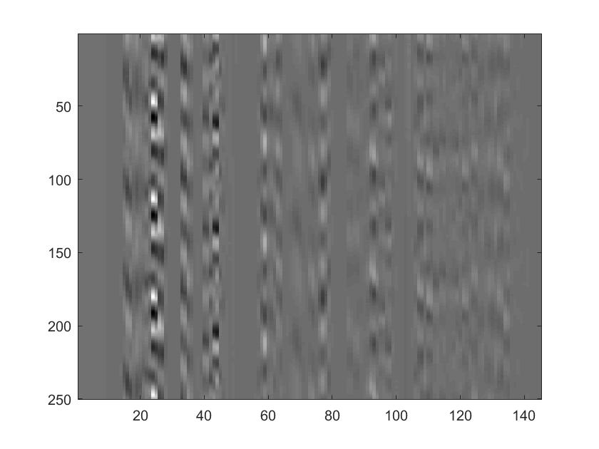
4.L=401

MATLAB CODE:

% Homework 3
% Window operations
% Zeyu Liu
% 10/8/2019

function homework3
% 1(a). window of length L.(L = 401)
L = 401;
h = zeros(L);
for n=1:L,
h(n) = 0.54 - 0.46*cos(2*pi*n/L);
end;
plot(h);
pause;

%or use tese is the same
%h1 = hamming(L);
%plot(h1);

% 1(b). Apply FFT
% h = hamming(L);
% plot(h1);
% pause;
h1 = double(hamming(L));
plot(h1);
pause;

% H = fft(h);
% logh = log(abs(H))+1;
% plot(logh);
% pause;
% plot(angle(H));
% pause;

H1 = fft(h1);
% plot magnitude
logh = log(abs(H1))+1;
plot(logh);
pause;
% plot phase
plot(angle(H1));
pause;

% 2. compute short-time energy and apply to the TIMIT speech sample
fname = 'LDC93s1.wav';
x = audioread(fname);
% short-time energy E = convolution(x^2(n)*h(n)), h(n) = w^2(n)
L = [51, 101, 201, 401];
for k = 1:4,
w = hamming(L(k));
h = w.^2;
y = conv(x.^2,h);
N = length(y);
for m = 1:floor(N/4),
energy(m) = y((m-1)*4+1);
end;
plot(x);
pause;
plot(energy);
pause;
end;

% 3. short-time zero-crossings
for k = 1:4,
w = hamming(L(k));
h = w.^2;
N = length(x)-1;
diff = zeros(1,N);
for n = 1:N,
diff(n) = abs(sign(x(n+1))-sign(x(n)));
end;
y = conv(diff,h);
M = length(y);
for m = 1:floor(M/4);
zc(m) = y((m-1)*4+1);
end;
plot(x);
pause;
plot(zc);
pause;
end;

% 4.compute short-time auto-correlation function
% test with TIMIT speech sample. Display results
% as a 2D image (time lag k as y axis, short-time
% index as x axis).

% short-time auto-correlation function:
% R = convolution(x(n)*x(n-k)) or convolution(x(n+k)*x(n))
fname = 'LDC93s1.wav';
x = audioread(fname);
L = [51, 101, 201, 401];
% time lag k as y axis, short-time index as x axis
for k1 = 1:4,
w = hamming(L(k1));
N = length(x)-640;
co = zeros(floor(N/320),250)
for i=1:320:N,
for k=1:250,
x1 = x(i:i+320);
y1 = conv(x1,w);
x2 = x(i+k:i+k+320);
y2 = conv(x2,w);
tk(k) = y1'*y2;
end;
co((i-1)/320+1,:) = tk; %
end;
imagesc(co');
colormap(gray);
pause;
end;

